FindBugs, CheckStyles, PMD, JaCoCo and sonarqube tools were under investigation.

1. Deployed SonarQube and added JaCoCo maven plugin to **Task1-abstractFactory** module
2. Built the project and did a first sonarqube measurement

Results:

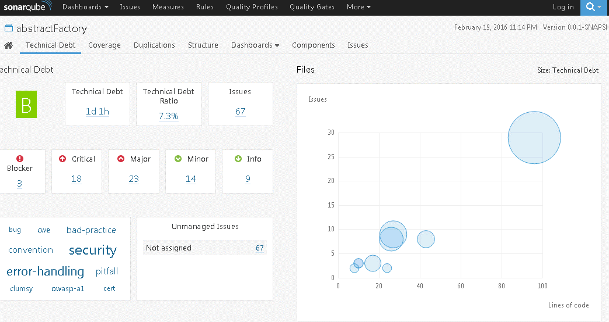

It rated code quality as B which not so bad and shows nice chart with project component and how many issues they have.

Some more charts

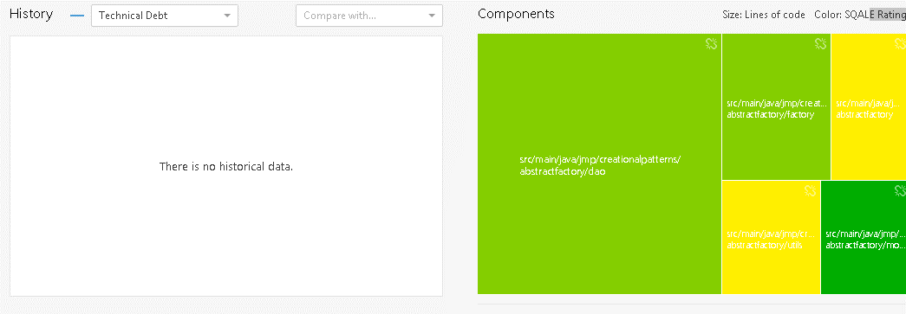

SonarQube is integrated with the JaCoCo plugin so it displayed Test Coverage report

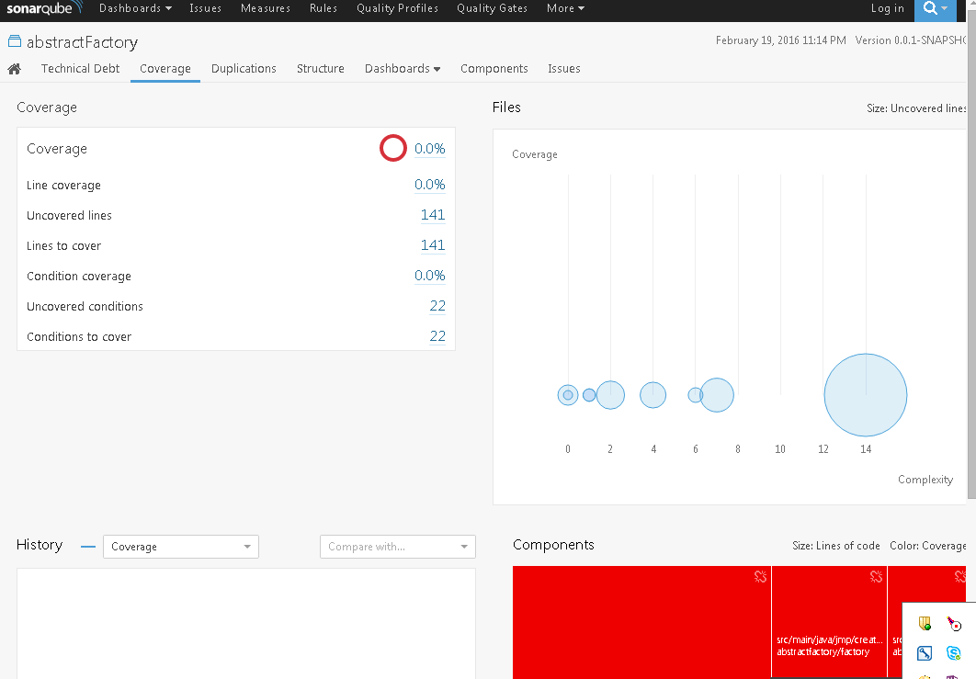

1. Started improve my code with FindBugs, CheckStyles, PMD tools. Integrated them in maven project and restarted build again. Build failed and generates plugin generated their reports:

FindBug:

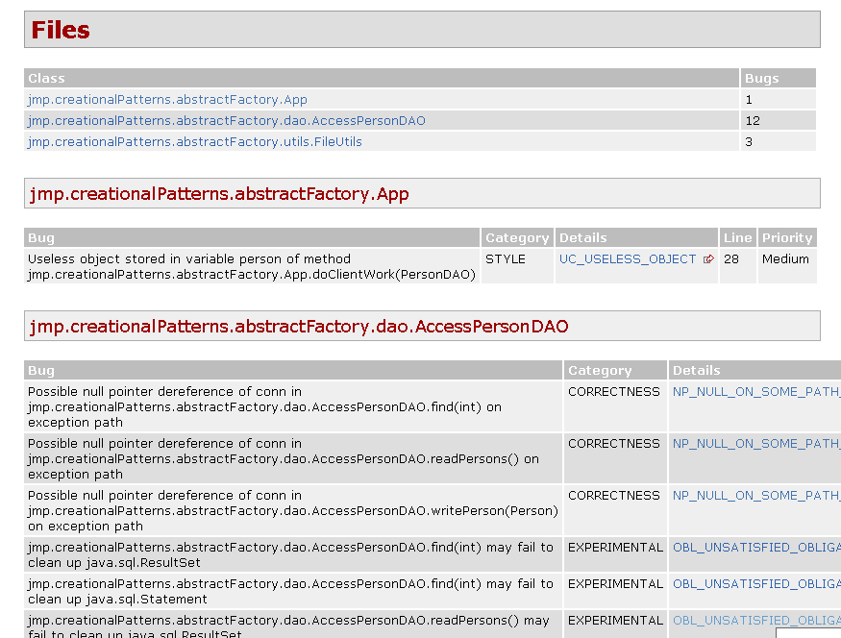

PMD:

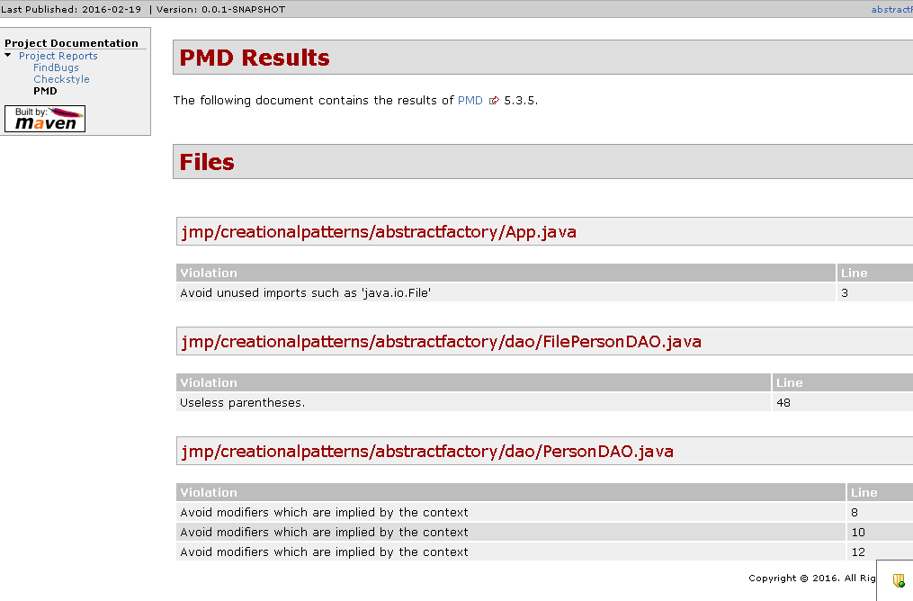

CheckStyles:

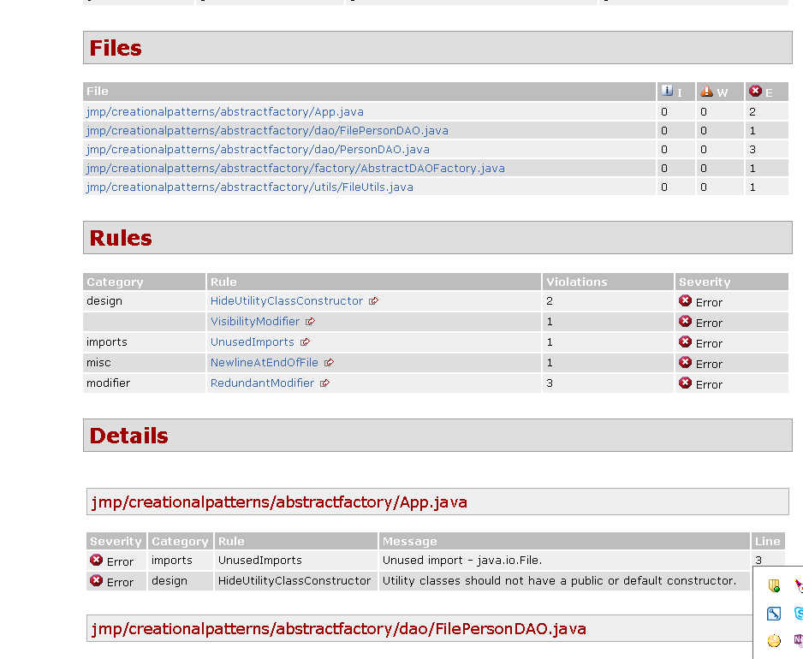

A lot of issue

1. Analyzed issues and fixed them (fixed tools rules in case of checkstyle. It has some controversial rules), added one unit test and rebuilt again. Build was SUCCESS. Did second sonarqube measurement.

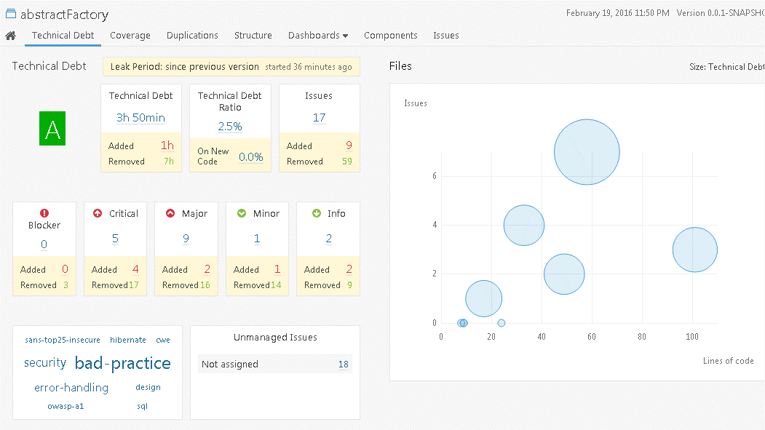

This time it rated my code as A, which is better than B, I believe. It showed how many issue are gone and how many appeared (can’t fix issue without making a new unfortunately)

Other charts:

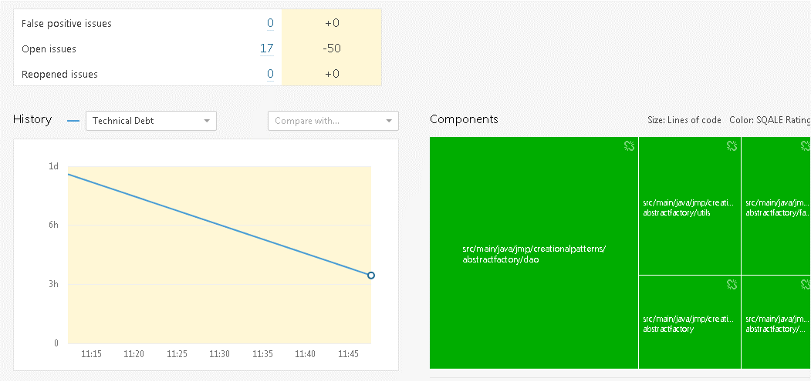

Amount of issues decreased - that is a right way

What about test coverage

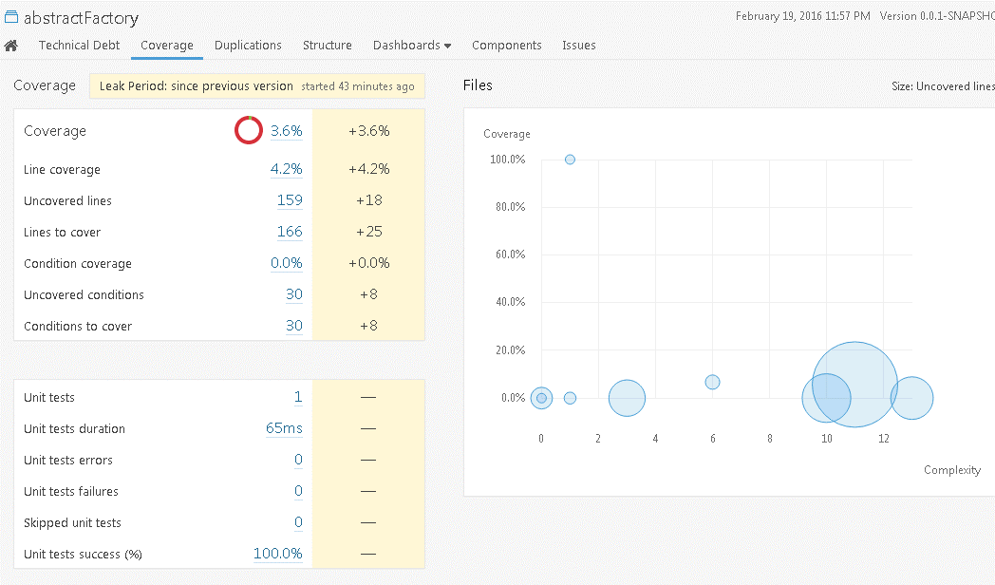

My one test did not save situation. However, direction is good

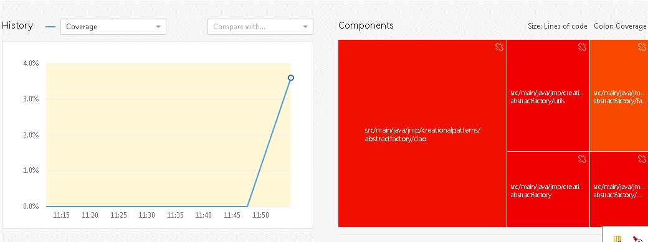

One rectangle even become orange.

1. See code changes in pull request.

**SUMMARY**

1. FindBugs, CheckStyles, PMD

Nice tools and can grow a code quality. It is very good to integrate them in build process then the project is in the beginning but if there much code already done and code does not match tool’s rule It can take A LOT OF time to fix all issues. So think it is better install them as a IDE plugin and check new code.

1. SonarQube

It impressed me with its really nice charts. So if we integrate it with CI we can see visually how code quality growing and be proud of yourself (hopefully)